**Q 1.1.1**

**The gaussian filters** removes high frequency components (such as sharp edges) from the image while maintains the low frequency components. **Laplacian filters** are derivative filters used to find areas of rapid change (edges) in images. Because high frequency components could be noisy, combining them with gaussian filter (Laplacian of Gaussian) reduces false signaling. **The derivatives** of x or y direction of gaussian filters captures the horizontal and vertical edges.

To obtain a scale space representation of the image, we use different scales applied on these filters. The motivation for different scales originates from the fact that real-world objects are of different sizes. There is a need for non-infinitesimal searching of details in the image.

**Q 1.1.2**

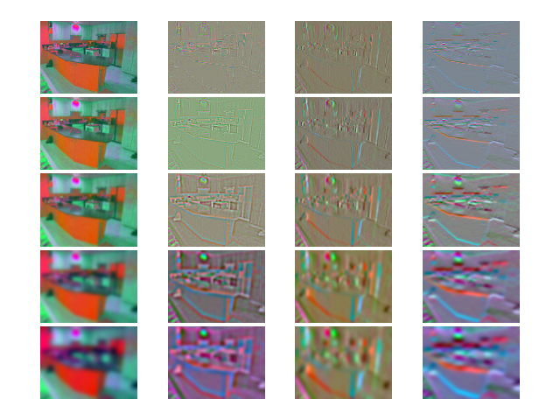

**Q 1.3**

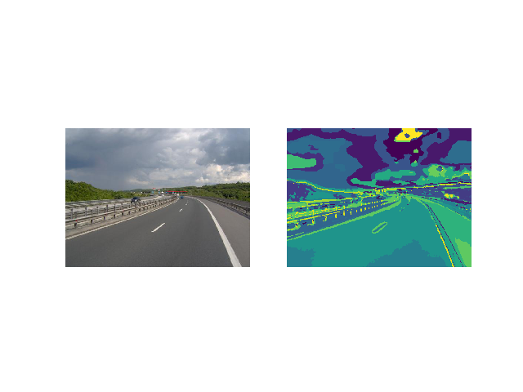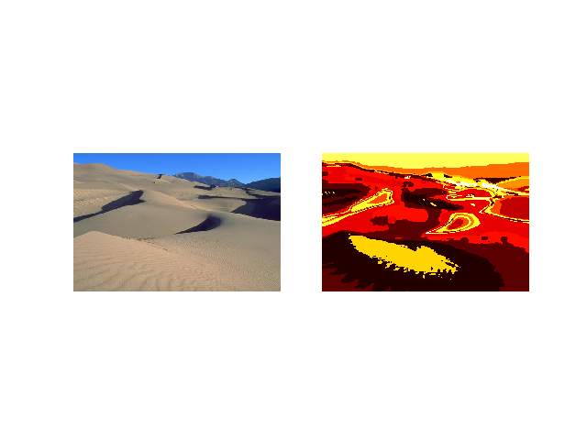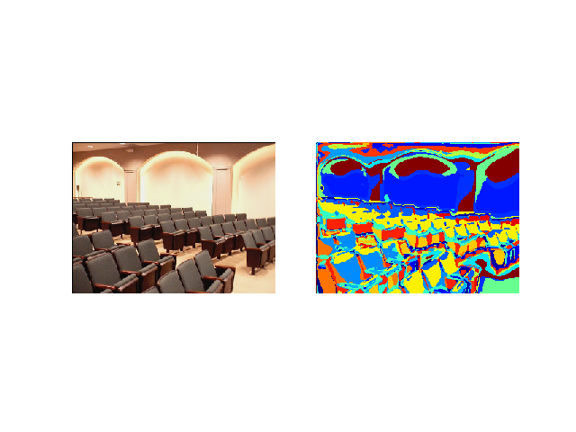

**Q 2.5**

Confusion matrix:

**[[ 11. 0. 1. 0. 3. 3. 2. 0.]**

**[ 0. 10. 0. 0. 0. 0. 0. 10.]**

**[ 1. 0. 10. 3. 2. 2. 0. 2. ]**

**[ 0. 0. 0. 13. 0. 0. 0. 7. ]**

**[ 6. 1. 0. 0. 11. 1. 1. 0. ]**

**[ 4. 0. 0. 0. 8. 7. 1. 0. ]**

**[ 1. 0. 0. 2. 0. 5. 11. 1. ]**

**[0. 0. 0. 6. 0. 0. 1. 13.] ]**

Accuracy: 0.5375

**Q 2.6**

From the confusion matrix, we can see that laundromat pictures have the lowest accuracies. Basically, these pictures have more unique edges and overall are noisy.

**Q 3.2**

**[[17. 0. 0. 1. 2. 0. 0. 0.]**

**[ 0. 18. 1. 1. 0. 0. 0. 0.]**

**[ 0. 0. 18. 2. 0. 0. 0. 0.]**

**[ 0. 0. 0. 20. 0. 0. 0. 0.]**

**[ 0. 0. 0. 0. 19. 1. 0. 0.]**

**[ 0. 0. 0. 0. 1. 19. 0. 0.]**

**[ 0. 0. 0. 0. 0. 0. 20. 0.]**

**[ 0. 0. 0. 1. 0. 0. 0. 19.]]**

Accuracy: 0.9375

The accuracy is better than BoW.

Pretrained VGG16 model has more training examples than just 1440 images. The features these convolutional layers capture can be more representative. Besides, deep layers of conv layers could filter out lots of noise. Bag of words algorithm depends heavily on the dictionary. In this assignment, we train dictionary with random signals from the training examples, which also discards a lot of spatial locality.